Android Assignment 6

Enroll No.: 2002283

1. Create a java android application to send email with attachment.

Activity_main.java

*<?*xml version="1.0" encoding="utf-8"*?>*<androidx.constraintlayout.widget.ConstraintLayout xmlns:android="http://schemas.android.com/apk/res/android"  
 xmlns:app="http://schemas.android.com/apk/res-auto"  
 xmlns:tools="http://schemas.android.com/tools"  
 android:layout_width="match_parent"  
 android:layout_height="match_parent"  
 tools:context=".MainActivity">  
  
 <EditText  
 android:id="@+id/et_to"  
 android:layout_width="390dp"  
 android:layout_height="46dp"  
 android:ems="10"  
 android:hint="Receivers Email Address"  
 android:inputType="textPersonName"  
 app:layout_constraintBottom_toBottomOf="parent"  
 app:layout_constraintEnd_toEndOf="parent"  
 app:layout_constraintHorizontal_bias="0.428"  
 app:layout_constraintStart_toStartOf="parent"  
 app:layout_constraintTop_toTopOf="parent"  
 app:layout_constraintVertical_bias="0.023" />  
  
 <EditText  
 android:id="@+id/et_subject"  
 android:layout_width="390dp"  
 android:layout_height="wrap_content"  
 android:layout_marginTop="20dp"  
 android:ems="10"  
 android:hint="Enter Subject"  
 android:inputType="textPersonName"  
 app:layout_constraintBottom_toBottomOf="parent"  
 app:layout_constraintEnd_toEndOf="parent"  
 app:layout_constraintHorizontal_bias="0.428"  
 app:layout_constraintStart_toStartOf="parent"  
 app:layout_constraintTop_toBottomOf="@+id/et_to"  
 app:layout_constraintVertical_bias="0.031" />  
  
 <EditText  
 android:id="@+id/et_message"  
 android:layout_width="390dp"  
 android:layout_height="262dp"  
 android:layout_marginTop="24dp"  
 android:ems="10"  
 android:gravity="top|left"  
 android:hint="Compose Email"  
 android:inputType="textMultiLine"  
 android:textAlignment="textStart"  
 app:layout_constraintBottom_toBottomOf="parent"  
 app:layout_constraintEnd_toEndOf="parent"  
 app:layout_constraintHorizontal_bias="0.428"  
 app:layout_constraintStart_toStartOf="parent"  
 app:layout_constraintTop_toBottomOf="@+id/et_subject"  
 app:layout_constraintVertical_bias="0.036" />  
  
 <Button  
 android:id="@+id/bt_send"  
 android:layout_width="wrap_content"  
 android:layout_height="wrap_content"  
 android:layout_marginStart="16dp"  
 android:layout_marginLeft="16dp"  
 android:layout_marginTop="24dp"  
 android:text="Send"  
 app:layout_constraintStart_toStartOf="parent"  
 app:layout_constraintTop_toBottomOf="@+id/et_message" />  
  
 <Button  
 android:id="@+id/bt_attachment"  
 android:layout_width="wrap_content"  
 android:layout_height="wrap_content"  
 android:layout_marginTop="24dp"  
 android:layout_marginEnd="16dp"  
 android:layout_marginRight="16dp"  
 android:text="Attachment"  
 app:layout_constraintEnd_toEndOf="parent"  
 app:layout_constraintTop_toBottomOf="@+id/et_message" />  
</androidx.constraintlayout.widget.ConstraintLayout>

MainActivity.java

package com.example.a6q1;  
  
import android.content.Intent;  
import android.database.Cursor;  
import android.net.Uri;  
import android.os.Bundle;  
import android.provider.MediaStore;  
import android.util.Log;  
import android.view.View;  
import android.widget.Button;  
import android.widget.EditText;  
import android.widget.Toast;  
  
import androidx.appcompat.app.AppCompatActivity;  
  
public class MainActivity extends AppCompatActivity {  
  
 EditText et_email;  
 EditText et_subject;  
 EditText et_message;  
 Button Send;  
 Button Attachment;  
 String email;  
 String subject;  
 String message;  
 String attachmentFile;  
 Uri URI **=** null;  
  
 private static final int ***PICK_FROM_GALLERY* =** 101;  
  
 int columnIndex;  
  
 @Override  
 protected void onCreate(Bundle savedInstanceState)  
 {  
  
 super.onCreate(savedInstanceState);  
 setContentView(R.layout.***activity_main***);  
 et_email **=** (EditText) findViewById(R.id.***et_to***);  
 et_subject **=** (EditText) findViewById(R.id.***et_subject***);  
 et_message **=** (EditText) findViewById(R.id.***et_message***);  
 Attachment **=** (Button) findViewById(R.id.***bt_attachment***);  
 Send **=** (Button) findViewById(R.id.***bt_send***);  
  
 //send button listener  
 Send.setOnClickListener(new View.OnClickListener() {  
 @Override  
 public void onClick(View v) {  
 sendEmail();  
 }  
 });  
  
 //attachment button listener  
 Attachment.setOnClickListener(new View.OnClickListener() {  
  
 @Override  
 public void onClick(View v) {  
 openFolder();  
 }  
 });  
 }  
  
 protected void onActivityResult(int requestCode, int resultCode, Intent data) {  
  
 super.onActivityResult(requestCode, resultCode, data);  
 if (requestCode **== *PICK_FROM_GALLERY* &&** resultCode **== *RESULT_OK***) {  
  
 Uri selectedImage **=** data.getData();  
 String[] filePathColumn **=** {MediaStore.Images.Media.***DATA***};  
 Cursor cursor **=** getContentResolver().query(selectedImage, filePathColumn, null, null, null);  
 cursor.moveToFirst();  
 columnIndex **=** cursor.getColumnIndex(filePathColumn[0]);  
 attachmentFile **=** cursor.getString(columnIndex);  
 Log.*e*("Attachment Path:", attachmentFile);  
 URI **=** Uri.*parse*("file://" **+** attachmentFile);  
 cursor.close();  
 }  
 }  
  
 public void sendEmail()  
 {  
 try  
 {  
 email **=** et_email.getText().toString();  
 subject **=** et_subject.getText().toString();  
 message **=** et_message.getText().toString();  
 final Intent emailIntent **=** new Intent(android.content.Intent.***ACTION_SEND***);  
 emailIntent.setType("plain/text");  
 emailIntent.putExtra(android.content.Intent.***EXTRA_EMAIL***,new String[] { email });  
 emailIntent.putExtra(android.content.Intent.***EXTRA_SUBJECT***,subject);  
  
 if (URI **!=** null) {  
 emailIntent.putExtra(Intent.***EXTRA_STREAM***, URI);  
 }  
  
 emailIntent.putExtra(android.content.Intent.***EXTRA_TEXT***, message);  
 this.startActivity(Intent.*createChooser*(emailIntent,"Sending email..."));  
 }  
  
 catch (Throwable t)  
 {  
 Toast.*makeText*(this, "Request failed try again: " **+** t.toString(),Toast.***LENGTH_LONG***).show();  
 }  
  
 }  
  
 public void openFolder()  
 {  
 Intent intent **=** new Intent();  
 intent.setType("image/*");  
 intent.setAction(Intent.***ACTION_GET_CONTENT***);  
 intent.putExtra("return-data", true);  
 startActivityForResult(Intent.*createChooser*(intent, "Complete action using"), ***PICK_FROM_GALLERY***);  
 }  
}

AndroidManifest.java

*<?*xml version="1.0" encoding="utf-8"*?>*<manifest xmlns:android="http://schemas.android.com/apk/res/android"  
 package="com.example.a6q1">  
  
 <uses-permission android:name="android.permission.INTERNET" />  
 <uses-permission android:name="android.permission.READ_EXTERNAL_STORAGE" />  
 <uses-permission android:name="android.permission.READ_INTERNAL_STORAGE" />  
 <uses-permission android:name="android.permission.ACCESS_NETWORK_STATE" />  
  
 <application  
 android:allowBackup="true"  
 android:icon="@mipmap/ic_launcher"  
 android:label="@string/app_name"  
 android:roundIcon="@mipmap/ic_launcher_round"  
 android:supportsRtl="true"  
 android:theme="@style/Theme.A6Q1">  
 <activity android:name=".MainActivity">  
 <intent-filter>  
 <action android:name="android.intent.action.MAIN" />  
 <category android:name="android.intent.category.LAUNCHER" />  
 </intent-filter>  
 </activity>  
 </application>  
  
</manifest>

Output:

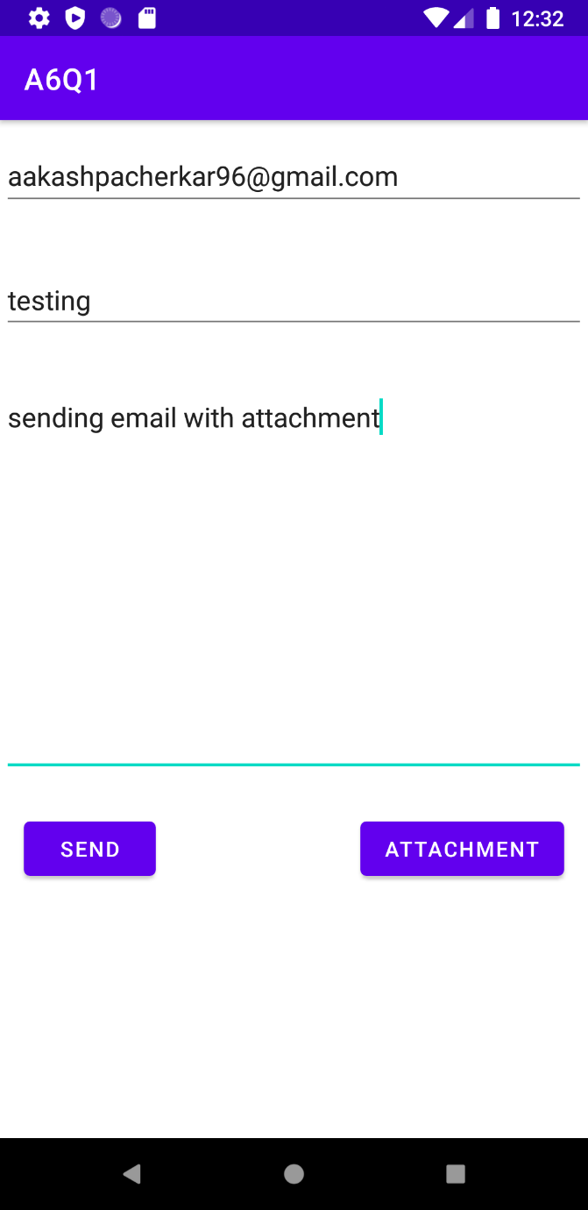 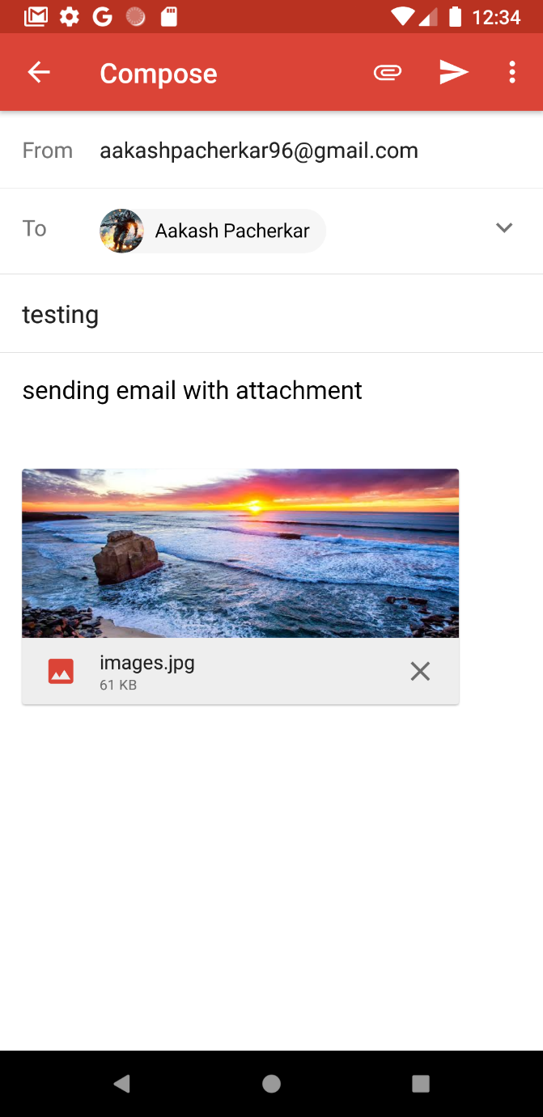

2. Create a java android application to display SMS from the Phone Numbers, which are in Your Contacts.

Activity_main.java

*<?*xml version="1.0" encoding="utf-8"*?>*<RelativeLayout xmlns:android="http://schemas.android.com/apk/res/android"  
 xmlns:app="http://schemas.android.com/apk/res-auto"  
 xmlns:tools="http://schemas.android.com/tools"  
 android:layout_width="match_parent"  
 android:layout_height="match_parent"  
 android:padding="30dp"  
 tools:context=".MainActivity">  
  
  
 <Button  
 android:id="@+id/btnshow"  
 android:layout_width="wrap_content"  
 android:layout_height="wrap_content"  
 android:text="Click to See SMS and Contacts"  
 android:textSize="20sp"  
 android:layout_marginTop="50dp"/>  
 <ListView  
 android:layout_width="wrap_content"  
 android:layout_height="300dp"  
 android:id="@+id/SMSlistView"  
 android:layout_marginTop="130dp"  
 />  
  
</RelativeLayout>

MainActivity.java

package com.example.a6q2;  
  
import androidx.appcompat.app.AppCompatActivity;  
import androidx.core.app.ActivityCompat;  
import androidx.core.content.ContextCompat;  
  
import android.content.ContentResolver;  
import android.content.pm.PackageManager;  
import android.database.Cursor;  
import android.net.Uri;  
import android.os.Bundle;  
import android.util.Log;  
import android.view.View;  
import android.widget.ArrayAdapter;  
import android.widget.Button;  
import android.widget.ListView;  
import android.widget.Toast;  
  
import java.util.ArrayList;  
  
public class MainActivity extends AppCompatActivity {  
 Button mbtnShow;  
 ListView mSMSListView;  
 ArrayAdapter arrayAdapter;  
 ArrayList**<**String**>** smsMessageList;  
 final int *REQUEST_CODE_ASK_PERMISSION* **=** 123;  
  
 @Override  
 protected void onCreate(Bundle savedInstanceState) {  
 super.onCreate(savedInstanceState);  
 setContentView(R.layout.***activity_main***);  
 smsMessageList**=**new ArrayList**<>**();  
 mSMSListView**=**findViewById(R.id.***SMSlistView***);  
 arrayAdapter**=**new ArrayAdapter**<**String**>**(this, android.R.layout.***simple_list_item_1***,smsMessageList);  
 mSMSListView.setAdapter(arrayAdapter);  
 mbtnShow**=**findViewById(R.id.***btnshow***);  
 mbtnShow.setOnClickListener(new View.OnClickListener() {  
 @Override  
 public void onClick(View v) {  
 if(ContextCompat.*checkSelfPermission*(getBaseContext(),"android.permission.READ_SMS")**==** PackageManager.***PERMISSION_GRANTED***)  
 {  
 refreshSMSInbox();  
 }  
 else  
 {  
 ActivityCompat.*requestPermissions*(MainActivity.this,new String[]{"android.permission.READ_SMS"},*REQUEST_CODE_ASK_PERMISSION*);  
 }  
 }  
 });  
 }  
  
 private void refreshSMSInbox()  
 {  
 ContentResolver contentResolver**=**getContentResolver();  
 Cursor cursor**=**contentResolver.query(Uri.*parse*("content://sms//inbox"),null,null,null,null);  
 int indexBody**=**cursor.getColumnIndex("body");  
 int indexAddres**=**cursor.getColumnIndex("address");  
 if(indexBody**<**0 **|| !**cursor.moveToNext())  
 return;  
 arrayAdapter.clear();  
 do {  
  
 String str**=**"SMS from:"**+**cursor.getString(indexAddres)**+**"\n"**+**cursor.getString(indexBody)**+**"\n";  
 //arrayAdapter.add(str);  
 smsMessageList.add(str);  
 mSMSListView.setAdapter(arrayAdapter);  
  
 }while (cursor.moveToNext());  
 }  
}

AndroidManifest.java

*<?*xml version="1.0" encoding="utf-8"*?>*<manifest xmlns:android="http://schemas.android.com/apk/res/android"  
 package="com.example.a6q2">  
  
 <uses-permission android:name="android.permission.READ_SMS"/>  
 <uses-permission android:name="android.permission.RECEIVE_SMS"/>  
  
 <application  
 android:allowBackup="true"  
 android:icon="@mipmap/ic_launcher"  
 android:label="@string/app_name"  
 android:roundIcon="@mipmap/ic_launcher_round"  
 android:supportsRtl="true"  
 android:theme="@style/Theme.A6Q2">  
 <activity android:name=".MainActivity">  
 <intent-filter>  
 <action android:name="android.intent.action.MAIN" />  
  
 <category android:name="android.intent.category.LAUNCHER" />  
 </intent-filter>  
 </activity>  
 </application>  
  
</manifest>

Output:

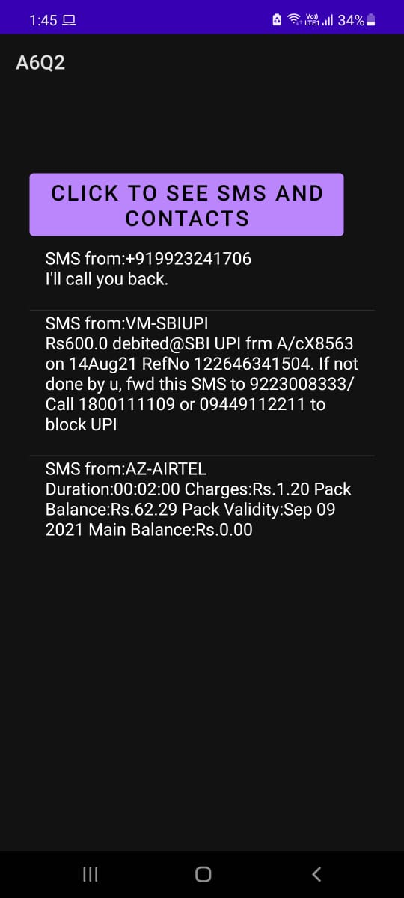

3. Create a java android application to send an SMS to the given mobile number.

Activity_main.java

*<?*xml version="1.0" encoding="utf-8"*?>*<androidx.constraintlayout.widget.ConstraintLayout xmlns:android="http://schemas.android.com/apk/res/android"  
 xmlns:app="http://schemas.android.com/apk/res-auto"  
 xmlns:tools="http://schemas.android.com/tools"  
 android:layout_width="match_parent"  
 android:layout_height="match_parent"  
 tools:context=".MainActivity">  
  
 <EditText  
 android:id="@+id/phoneNo"  
 android:layout_width="343dp"  
 android:layout_height="46dp"  
 android:layout_marginTop="68dp"  
 android:ems="10"  
 android:hint="Enter phone number"  
 android:inputType="textPersonName"  
 app:layout_constraintEnd_toEndOf="parent"  
 app:layout_constraintStart_toStartOf="parent"  
 app:layout_constraintTop_toTopOf="parent" />  
  
 <EditText  
 android:id="@+id/msg"  
 android:layout_width="349dp"  
 android:layout_height="50dp"  
 android:layout_marginTop="20dp"  
 android:ems="10"  
 android:hint="Enter message"  
 android:inputType="textPersonName"  
 app:layout_constraintEnd_toEndOf="parent"  
 app:layout_constraintStart_toStartOf="parent"  
 app:layout_constraintTop_toBottomOf="@+id/phoneNo" />  
  
 <Button  
 android:id="@+id/btn"  
 android:layout_width="161dp"  
 android:layout_height="47dp"  
 android:layout_marginTop="48dp"  
 android:text="Send SMS"  
 app:layout_constraintBottom_toBottomOf="parent"  
 app:layout_constraintEnd_toEndOf="parent"  
 app:layout_constraintHorizontal_bias="0.498"  
 app:layout_constraintStart_toStartOf="parent"  
 app:layout_constraintTop_toBottomOf="@+id/msg"  
 app:layout_constraintVertical_bias="0.068" />  
</androidx.constraintlayout.widget.ConstraintLayout>

MainActivity.java

package com.example.smstrial;  
  
import androidx.annotation.NonNull;  
import androidx.appcompat.app.AppCompatActivity;  
import androidx.core.app.ActivityCompat;  
import androidx.core.content.ContextCompat;  
  
import android.Manifest;  
import android.content.pm.PackageManager;  
import android.os.Bundle;  
import android.telephony.SmsManager;  
import android.view.View;  
import android.widget.Button;  
import android.widget.TextView;  
import android.widget.Toast;  
  
public class MainActivity extends AppCompatActivity {  
  
 Button btn;  
 TextView phoneNo, msg;  
  
 @Override  
 protected void onCreate(Bundle savedInstanceState) {  
 super.onCreate(savedInstanceState);  
 setContentView(R.layout.***activity_main***);  
  
 btn **=** findViewById(R.id.***btn***);  
 phoneNo **=** findViewById(R.id.***phoneNo***);  
 msg **=** findViewById(R.id.***msg***);  
  
 btn.setOnClickListener(new View.OnClickListener() {  
 @Override  
 public void onClick(View v) {  
 if(ContextCompat.*checkSelfPermission*(MainActivity.this, Manifest.permission.***SEND_SMS***) **==** PackageManager.***PERMISSION_GRANTED***) {  
 sendSMS();  
 }  
 else {  
 ActivityCompat.*requestPermissions*(MainActivity.this, new String[]{Manifest.permission.***SEND_SMS***}, 100);  
 }  
 }  
 });  
 }  
  
 private void sendSMS() {  
 String phoneNum **=** phoneNo.getText().toString().trim();  
 String message **=** msg.getText().toString().trim();  
 if (**!**phoneNum.equals("") **&& !**message.equals("")) {  
 SmsManager smsManager **=** SmsManager.*getDefault*();  
 smsManager.sendTextMessage(phoneNum, null, message, null, null);  
 Toast.*makeText*(this, "Sms sent!!", Toast.***LENGTH_LONG***).show();  
 }  
 else {  
 Toast.*makeText*(this, "Enter details", Toast.***LENGTH_SHORT***).show();  
 }  
 }  
  
 @Override  
 public void onRequestPermissionsResult(int requestCode, String[] permissions, int[] grantResults) {  
 super.onRequestPermissionsResult(requestCode, permissions, grantResults);  
  
 if(requestCode**==**100 **&&** grantResults.*length***>**0 **&&** grantResults[0]**==**PackageManager.***PERMISSION_GRANTED***)  
 {  
 sendSMS();  
 }  
 else {  
 Toast.*makeText*(getApplicationContext(),"Failed to send",Toast.***LENGTH_LONG***).show();  
 }  
 }  
}

AndroidManifest.java

*<?*xml version="1.0" encoding="utf-8"*?>*<manifest xmlns:android="http://schemas.android.com/apk/res/android"  
 package="com.example.smstrial">  
 <uses-permission android:name="android.permission.SEND_SMS"/>  
  
 <application  
 android:allowBackup="true"  
 android:icon="@mipmap/ic_launcher"  
 android:label="@string/app_name"  
 android:roundIcon="@mipmap/ic_launcher_round"  
 android:supportsRtl="true"  
 android:theme="@style/Theme.SmsTrial">  
 <activity android:name=".MainActivity">  
 <intent-filter>  
 <action android:name="android.intent.action.MAIN" />  
  
 <category android:name="android.intent.category.LAUNCHER" />  
 </intent-filter>  
 </activity>  
 </application>  
  
</manifest>

Output: (SMS sent on my own mobile number – self SMS)

Note: SMS viewed using Q2 app.

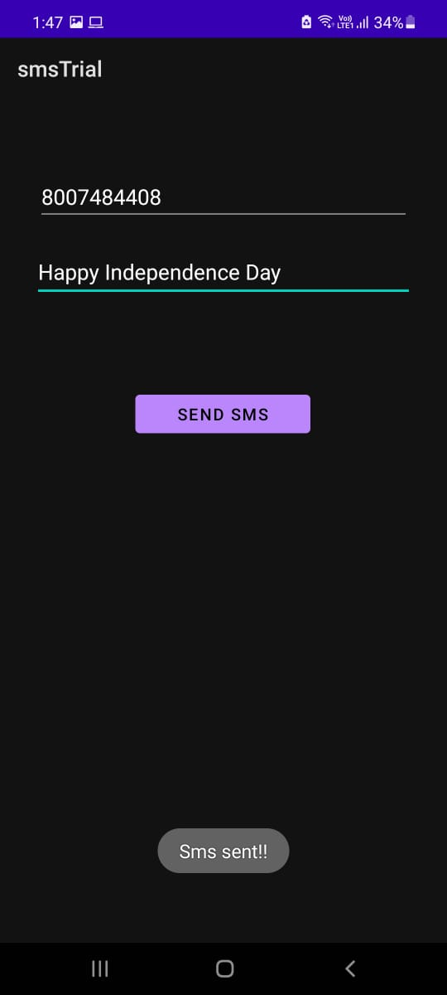 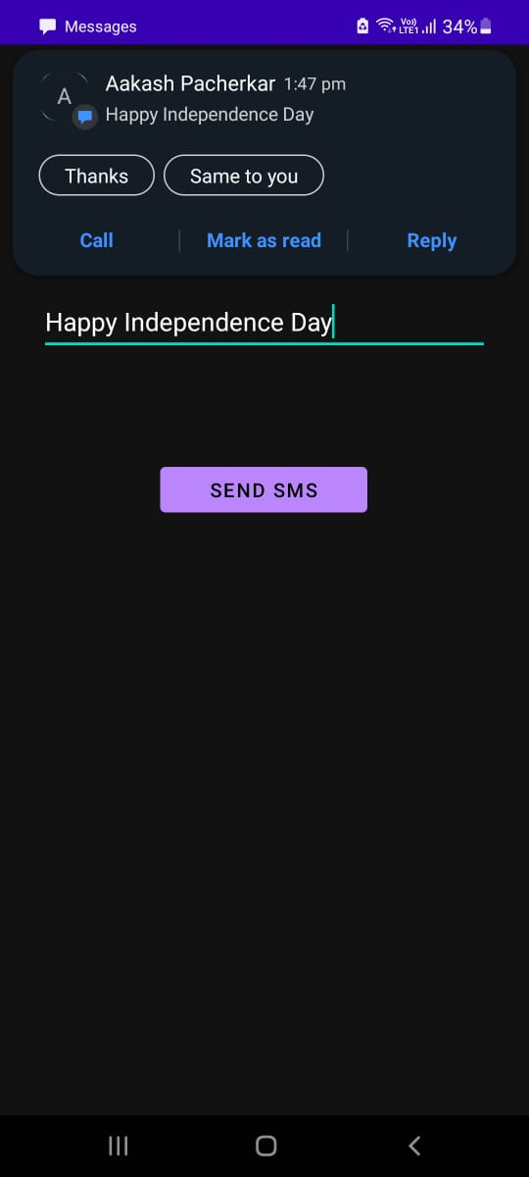

Viewing SMS using Q2 app:

